Fig. 1 Analysis of escape depth (δ). (a) Si 1s and (b) O 1s HX-PES spectra as a function of a-IGZO film thickness. (c) Signal intensity as a function of film thickness. (Symbols) Experimental data obtained from (a) and (b), and (solid lines) theoretical data following the relation $I(d)=A\text{exp}\left({−d}/δ\right)$ for (circles) Si 1s at 1844.5 eV and (triangles) O 1s at ~530 eV.

In XPS measurements, number of photoemitted electrons is measured as a function of kinetic energy, which is converted to binding energy of the initial state. As the photoexcited electrons are scattered and relaxed in the material, the number of ballistic electrons emitted to vacuum decays with the exponential law, $I(x)=I_{0}\text{exp}\left({−x}/δ\right)$, where x denotes the distance from the surface, δ the escape depth, and I₀ a constant. For a film with a thickness of d on an infinite substrate, the HX-PES signal from the substrate is expressed as $I=\int{I\left(x\right)\text{dx}}=I_{0}δ\text{exp}\left({−d}/δ\right)$. Therefore, δ is determined using a-IGZO film / SiO₂ / c-Si samples with varied a-IGZO film thickness’, where the thickness of the SiO2 layer (?? nm) is large enough to be regarded as an infinite substrate. Figures 1(a,b) show Si 1s peaks around 1844 eV and O 1s peaks around 531 eV. The O 1s peaks are split to two peaks each at 533 eV and 530 eV, respectively, which are attributed to the Si-O bond in the SiO₂ substrate and the metal – O bonds (M-O) in the a-IGZO films [ref], which is confirmed by the fact that the intensity of the former decreases with increasing the a-IGZO thickness while that of the latter is nearly unchanged. The intensities of the Si, Si-O, and M-O peaks were deconvoluted using Gaussian-type functions, and those of the Si 1s and the Si-O peaks are plotted as a function of the a-IGZO film thickness in Fig. 1(c). It follows well the exponential law. The deviation for the Si-O peak intensity at the large d value is due to the background effect because the M-O peak has a tail in the high energy region as seen in the HX-PES spectra for the thick (d ≥ 47 nm) films. This result provides the δ values of 5.7 nm for the Si 1s peak and 5.9 nm for the Si-O 1s peak. The small dependence on the binding energy is reasonable for HX-PES measurement because the kinetic energies are similar (6095 eV and 7410 eV, respectively) due to the large exciation energy of 7940 eV.

This fact, i.e. higher density defect states exist in the surface region than in the bulk region. Figure 3(d) shows he depth distributions of the near-VBM states D(x) extracted from the data in Figs. (a-c) by the following procedure. We assumed a simple exponential distribution, $D\left(x\right)=a\text{exp}\left({−x}/l\right)$, where a is a constant and l the distribution depth. We first incorporated a constant background, but the c values were converged to negligibly small values and turned out to be not necessary. In this case, the observed signal intensity is expressed as $I\left(θ\right)=\int{D\left(x\right)I\left(x_{\text{eff}}\right){\text{dx}}_{\text{eff}}}={\text{aI}}_{0}\int{\text{exp}\left({−x_{\text{eff}}}/δ\right)\text{exp}\left(−x_{\text{eff}}\text{sin}θ/l\right){\text{dx}}_{\text{eff}}}$, where x_{eff} measures the effective distance from the surface at the angle of θ$x_{\text{eff}}=x\text{/sin}θ$, where x denotes the normal depth from the surface. It gives
$I\left(θ\right)={\text{al}}_{\text{eff}}I_{0}\left[1−\text{exp}\left({−d}/{l_{\text{eff}}}\right)\right]$, (1)
where $l_{{\text{eff}}^{−1}}=δ^{−1}+{\left(l\text{/sin}θ\right)}^{−1}$. For the uniform, infinite case ($l→∞$,$d→∞$),$I_{\text{avg}}={aδI}_{0}$ is obtained, which corresponds to the average state densities discussed above. The experimental I(θ) were extracted from the data in Figs. (a-c) by deconvolution and are plotted as a function of x_{esc} in Fig. (d). It shows that eq. (1) explains well the experimental data with the l value of 0.46 nm. The extracted depth distribution D(x) , which is converted to the average state density I_{avg} in cm⁻³, is plotted in Fig. (e) as a function of normal depth from the surface. This result indicate that the near-VBM states observed in Figs. 2(b) and 3(a-c) are concentrated at the surface regions of the a-IGZO films. The trend is the same as the discussion for the average state densities in Fig. 2(b); i.e., the state density is the largest for the as-deposited film with the surface value of 5×10²¹ cm⁻³ and the smallest for the wet-annealed film with that of 1×10²¹ cm⁻³, which are decreased to ~10¹⁸ cm⁻³ at the normal depth of ~3.2 nm.
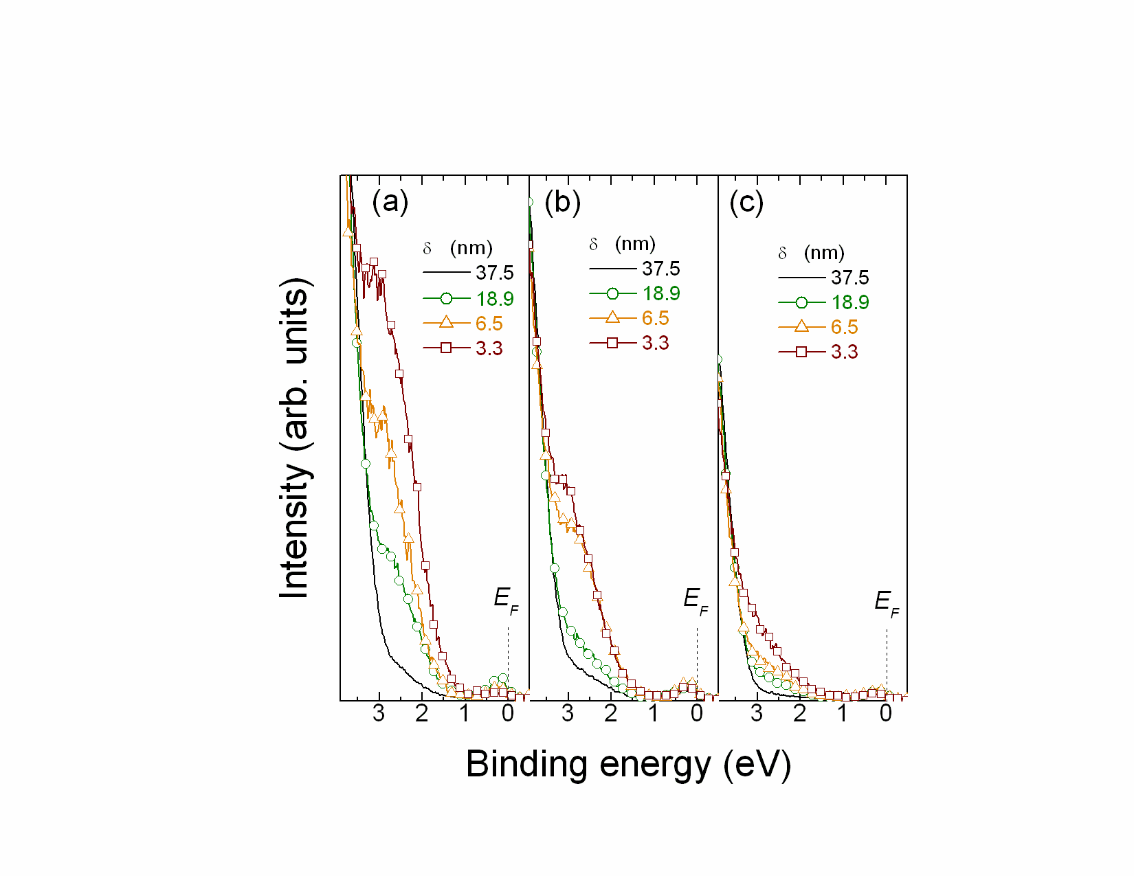
Figure 3 HX-PES spectra at several escape depths (δ) for (a) unannealed, (b) dry annealed, and (c) wet annealed films. (d) Signal intensities of the near-VBM states as a function of the effective escape depths defined by $d_{\text{eff}}=δ\text{sin}θ$. (Symbols) The values obtained by deconvoluting Figs. (a-c), and (lines) the fitting results. (e) Depth distributions of the near-VBM state densities extracted from the fitting analyses of (d).

3.4 O 1s core level spectra
Figure 4 shows angle-resolved HX-PES spectra of the O 1s core levels corresponding to the films and δ‘s in Figs. 2(a-c). Each O1s core level consisted of two peaks. For the unannealed film at δ ~ 5.8 nm, a main peak is located around ~531.6 eV, while an additional peak appears at a larger binding energy. The main peaks arise from the 1s levels of the O ions that form metal – oxygen (In-O, Ga-O and Zn-O) bonds, while the additional peaks at ~532.2 eV are attributed to –OH bonds or O²⁻ in oxygen-deficient regions [REF]. However, we believe that the annealed films were strongly oxidized by O₂ and H₂O atmospheres. Thus, we consider that the additional peaks at ~532.2 eV are attributed to –OH bonds.
It should be noticed that the signal intensities of the –OH bonds increased with approaching the film surfaces in all the films, which is similar to the case of the near-VBM states. Particularly, very intense –OH bond signals are observed in the vicinity of the film surface for the wet annealed film. These results indicate that a large amount of –OH bonds exists near the film surface. Therefore, we consider that the H₂O molecules in the wet O₂ gas terminated a part of the surface defects such as oxygen vacancy and reduced the subgap DOS above VBM. On the other hands, the others such as In 3d, Ga 2p, and Zn 2p core levels showed only one peak each that is attributed to the metal – oxygen bonds, and no metallic states were detected in all the films (data not shown).
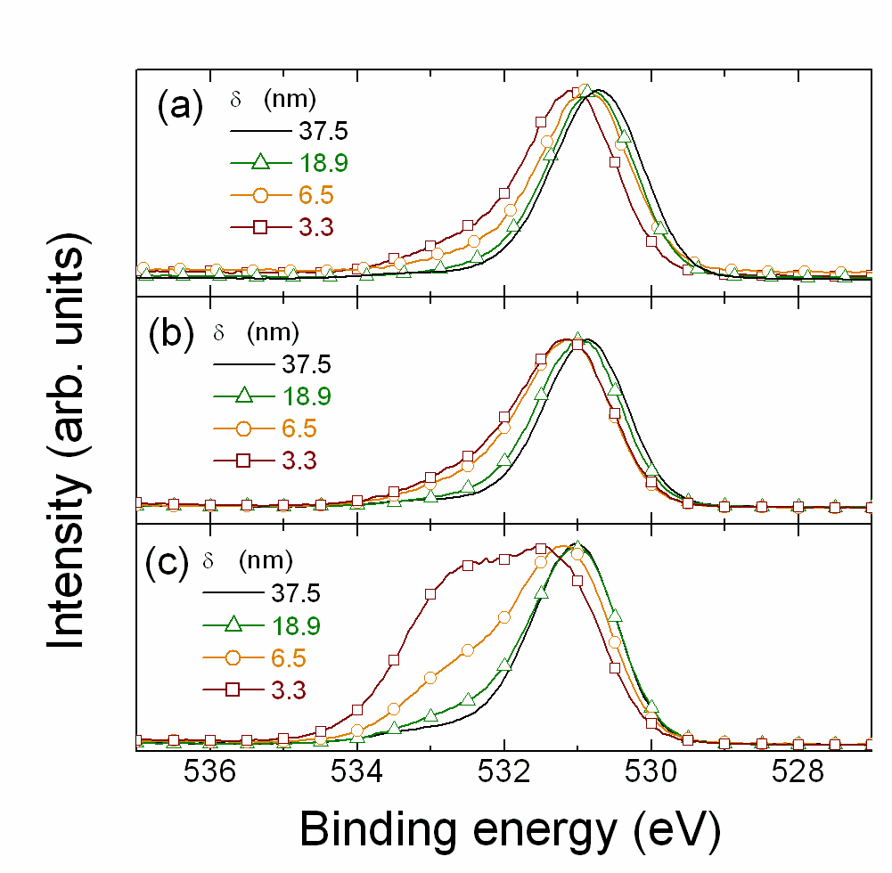
Figure 4 O 1s core level spectra at several X-ray penetration depths (δ) for (a) unannealed, (b) dry annealed, and (c) wet annealed films.

We also found apparent positive shifts (i.e., shift to deeper energies) in the peak binding energies with approaching the film surfaces in all the core levels for all the films. The binding energy shifts (ΔE_{B.E.}) for the VBM and the core levels are plotted as a function of the normal escape depth (δ⊥) for the unannealed films in Fig. 5(a). The VBM and all the core levels shift in parallel by ~ +0.2 eV with approaching the film surfaces. It suggests that the peak shift of the core levels originate from the Fermi level shifts, which indicates ~ 0.2 eV of down band bending toward the film surface. Figure 5(b) shows the schematic illustration of the band structure built from the above observations.
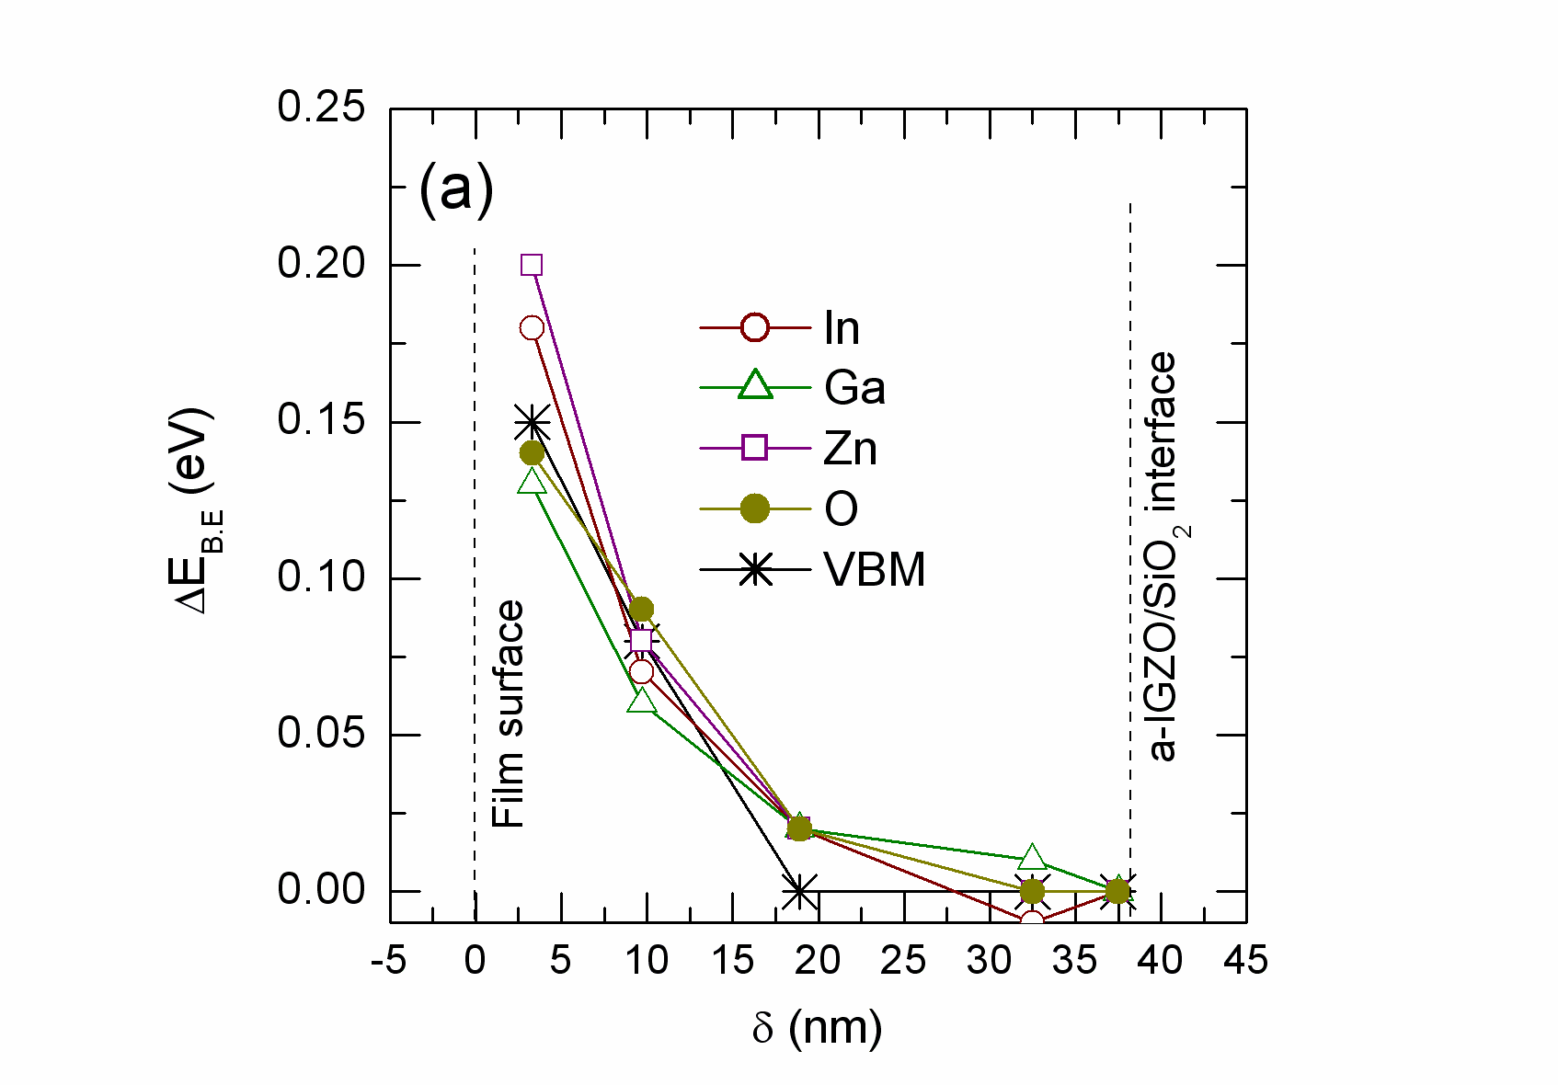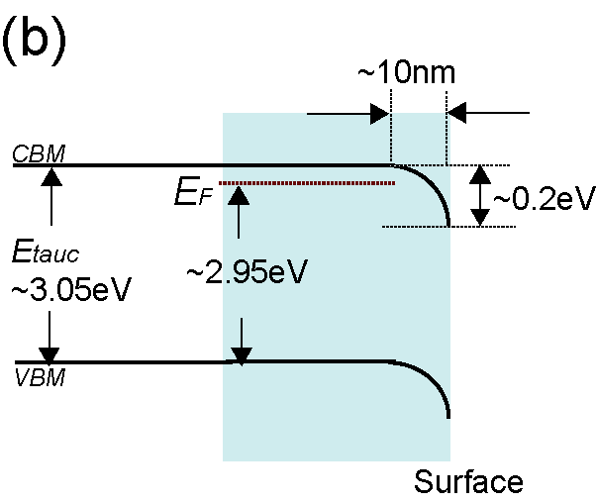
Figure 5 (a) Binding energy shift (ΔE_{B.E.}) as a function of the normal escape depth (δ⊥) for the unannealed films. The ΔE_{B.E.} is defined as the energy shift with respect to the data at δ⊥ = 5.8 nm. (b) Schematic illustration of band structure deduced from (a).

3.5 Near-CB states
Next, we discuss the near-CBM states observed in Fig. 2(b), which are shown in Fig. 6 for the unannealed, dry annealed, and wet annealed films at varied δ (5.8 – 0.5 nm). The densities (i.e. the integrated peak areas) do not decrease with increasing the normal escape depth, suggesting that the near-CBM states do not relate to the surface states and contaminations. Moreover, their shapes and widths are also similar for these films irrespective of the different film qualities (i.e., the different annealing treatments). Similar results are observed also for the crystalline oxide semiconductors, sc-IGZO film, ZnO single crystal, and ZnO epitaxial films, as shown in Fig. 7(a). It suggests that the near-CBM staes do not relate to the disordered structures in the a-IGZO.

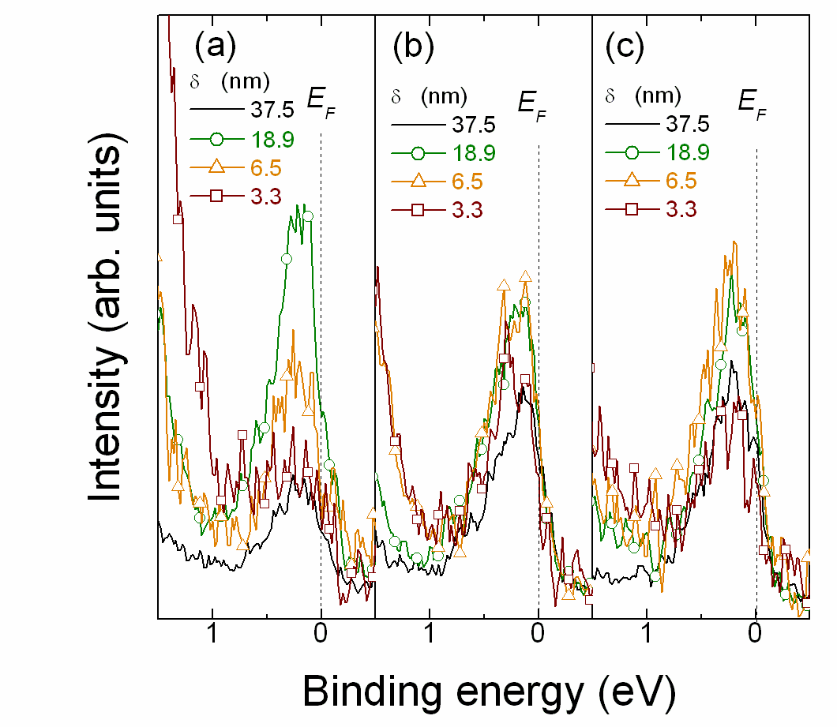
Figure 6 Near-CBM states as a function of normal escape depth (δ⊥) for (a) unannealed, (b) dry annealed, and (c) wet annealed films.

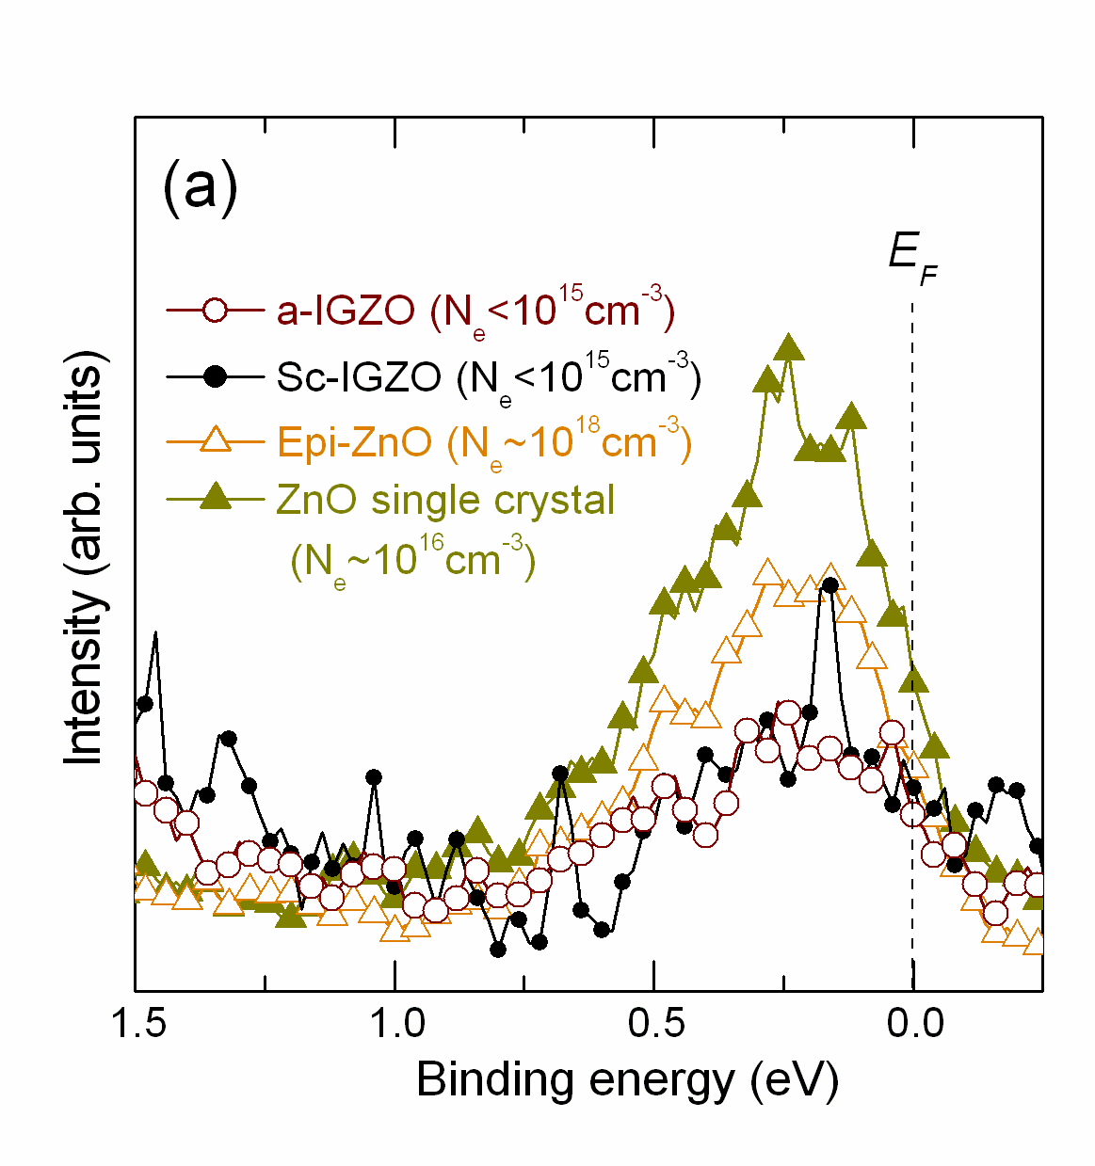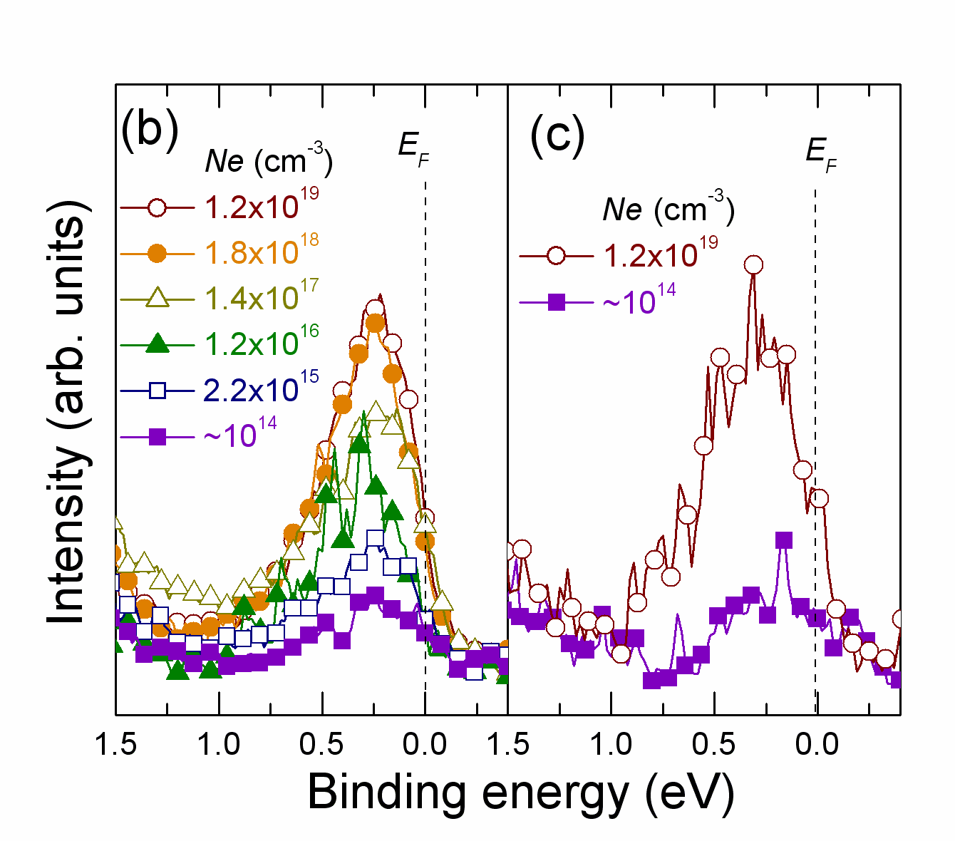
Figure 7 (a) Comparison of near-CBM states for a-IGZO and sc-IGZO films. Those for ZnO single crystal and epitaxial film are also shown. (b) near-CBM states for a-IGZO and sc-IGZO films with different carrier concentrations.

Figure 7(b) shows the near-CBM states for the a-IGZO and sc-IGZO with different N_{e}. The near-CBM states increase with increasing N_{e} (Fig. 7(b)), but it is not likely that the signals come from the free electrons or donors. In a-IGZO, the electron concentration is degenerated and E_{F} exceeds the conduction band bottom at N_{e} > 10¹⁷ cm⁻³ [REF], which means that all the donors are ionized and their signals should not be observed by PES. The remaining possibilities are that we observe the free electrons in the conduction band or the electrons trapped by localized states extending from the E_{F}. However, the integrated areas of the near-CBM states are nearly unchanged even if N_{e} increases from 10¹⁷ to 10¹⁹ cm⁻³. In addition, our estimation of the densities of the near-CBM states provided ~5×10¹⁹ cm⁻³ for the highest-quality film with the lowest N_{e} of ~10¹⁶ cm⁻³; there is a more than three orders of magnitude of the discrepancy, and therefore we consider it is hard to assign the extra DOS to the free electrons in the conduction band.

We like to note that the existence of such high-density near-CBM states contradict with the operation characteristics of a-IGZO TFTs. Using a TFT simulator (SILVACO, ATLAS), we modeled a top contact and bottom gate TFT structure with a SiO₂ gate insulator 150 nm in thickness based on the parameters described in [REF]. Considering the HX-PES results showing the near-CBM states, we simulated TFT characteristics for two different subgap states models. One has only a donor-type DOS, which corresponds to the near-CBM states (Fig. 8(a)). The other is a more realistic case, i.e. combined DOS composed of donor-type and acceptor-type traps (Fig. 8(b)). If these extra DOSs come from the trap states just below the E_{F} as shown in Fig. 8(b), they pin the Fermi level and prohibit to alter N_{e} in the TFT channel when gate bias is applied; i.e., the off current can not be reduced to < 10⁻¹² A e.g. at V_{GS} down to -10 V (see the blue line in Fig. 8(c) <= 青線はない). Moreover, even the case of the combined DOS is hard to explain the measured curves.
Therefore, we should consider another possibility for the near-CBM states. One possibility would be that the near-CBM states are formed in the vacuum chamber and do not exist in the channel region in the actual TFTs; however, as discussed for Fig. 6, the signals of the near-CBM states do not decrease with increasing the normal depth from the surface, which indicates that the near-CBM states exist constantly in the bulk regions of the a-IGZO films at least deep to 5.8 nm from the surface. These consideration leads to the conclusion that the near-CBM states should neither be attributed to the donor states, the free electrons in the conduction band nor the trap states at least in the actual TFTs. A possibility is that these near-CBM states are formed transiently by the irradiation of the high-energy X-ray or by the reducing atmosphere of vacuum. Actually, we observed very slow photoresponse extending to several thousands seconds in sc-IGZO and a-IGZO films [ref: TOEO6, Lee] and a similar slow photoresponse is also reported for single-crystal ZnO [ref from Lee’s paper], which would accumulate photoexcited electrons with the concentrations detectable by the HX-PES.
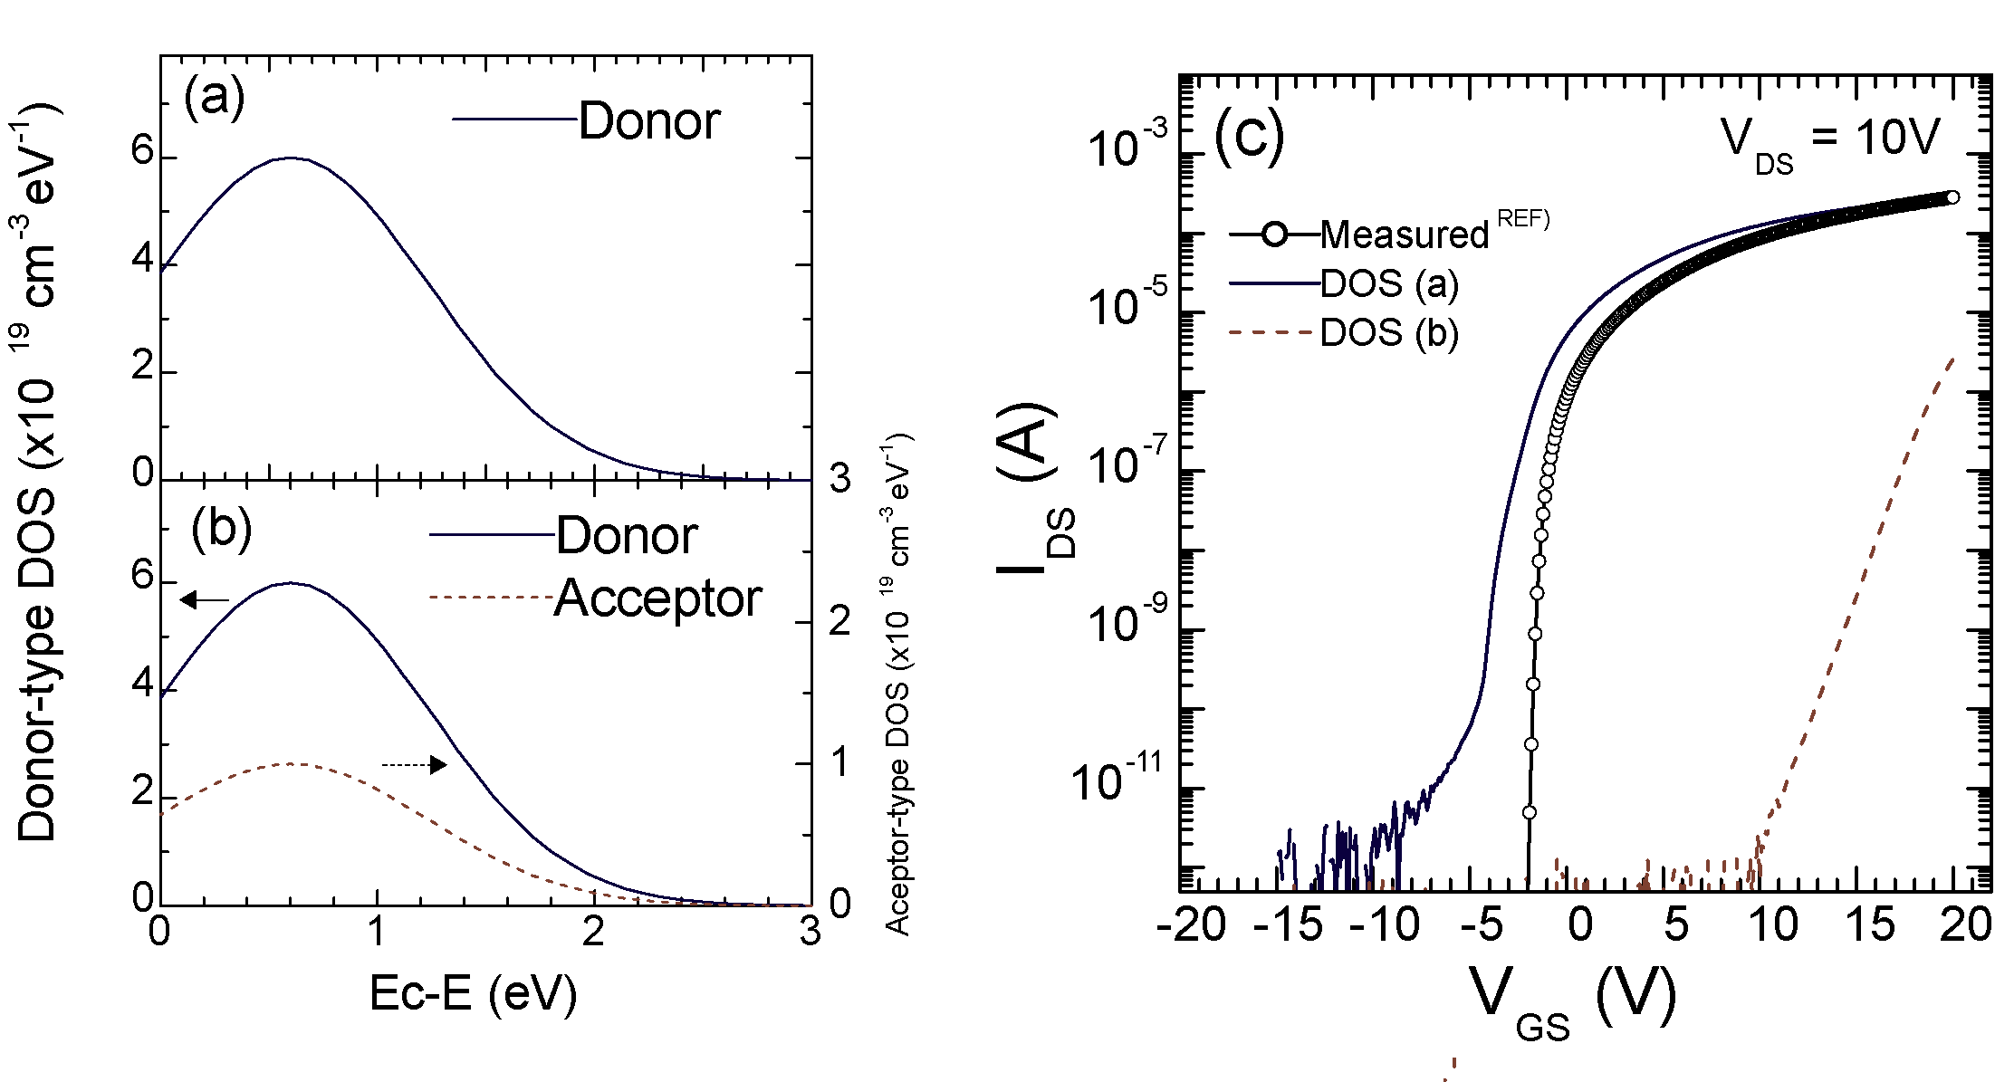
Figure 8 TFT simulation based on the subgap DOS below E_{F} observed by HX-PES. (a,b) DOS models (a) that consider only occupied states, and (b) that consider occupied and unoccupied states. (c) Simulated TFT characteristics based on the subgap DOSs in (a,b). The observed result is shown for comparison [ref].

4. Conclusions
The subgap electronic structures for the unannealed, dry and wet oxygen annealed a-IGZO films was investigated by HX-PES using hv=7940 eV. It was found that a-IGZO had extra subgap DOS near the VBM. The unannealed films had somewhat lager subgap DOS of ~7x10²⁰ cm⁻³ and the DOS were largely increased with approaching the film surfaces. The thermal annealing significantly reduced the subgap DOS, which are ~5x10²⁰cm⁻³ for the dry annealed and ~2x10²⁰cm⁻³ for the wet annealed films. In particular, the wet annealing with wet oxygen gas well suppressed the formation of defect state by –OH termination. Extra state near Fermi levels was also investigated. It was found that the extra state does not relate to surface state and disordered structures, but their origin remains to be clarified.

