Chapter 1: Mastering Generative AI

Introduction
This lecture focuses on a revolutionary tool that is reshaping research, analysis, and communication: Generative Artificial Intelligence (gen-AI).
The goal of this lecture is not simply to list what AI can do, but to teach you how to use it as a sophisticated partner in your academic journey. We will explore how to harness its power to broaden your discussions, deepen your analysis, and ultimately, become more effective and creative scientists and engineers. Think of Generative AI not as an oracle that provides answers, but as a tireless collaborator that helps you ask better questions.

1.1 The Versatile Capabilities of Generative AI
Generative AI, powered by Large Language Models (LLMs), has a wide array of applications that can significantly enhance academic and professional productivity. Let’s explore some of its primary functions relevant to our field:
- Text Refinement:
  - Proofreading and Formatting: AI can instantly correct grammatical errors, improve sentence structure, and format documents according to specific styles (e.g., Nature, APL, IEEE), which is invaluable when preparing lab reports or research papers.
  - Summarizing and Translating: It can condense lengthy research articles into concise abstracts or translate papers from other languages, breaking down knowledge barriers.
- Content Creation:
  - Drafting Documents: It can generate first drafts of emails, meeting agendas, presentation scripts, or even sections of a research proposal, saving you valuable time.
  - Data Generation: For computational studies, AI can create synthetic datasets that follow specific statistical distributions. This is useful for testing algorithms or simulating scenarios where real-world data is scarce.
- Creative and Technical Generation:
  - Visual and Audio Content: AI models can create images, diagrams, and charts to visually represent data or concepts. This is particularly useful for presentations and publications.
  - Mathematical Derivations: You can ask AI to walk you through the steps of a complex mathematical proof or derive a formula, which can be a powerful learning aid.
  - Code Generation: It excels at writing and debugging code in various languages like Python, C++, Javascript, MATLAB etc, which are essential for data analysis and modeling in materials science. It can write a script to plot experimental data or implement a simple simulation.

Examples in Practice
To make this tangible, let’s look at how we are already implementing these tools in our curriculum:
- SSS Global Forum (Group Discussion Platform): We use a web-based AI tool to facilitate and analyze group discussions. It can help summarize key points, identify areas of consensus or disagreement, and ensure all voices are heard.
http://d2mate.mdxes.iir.isct.ac.jp/Lecture/GlobalSSS/index.html
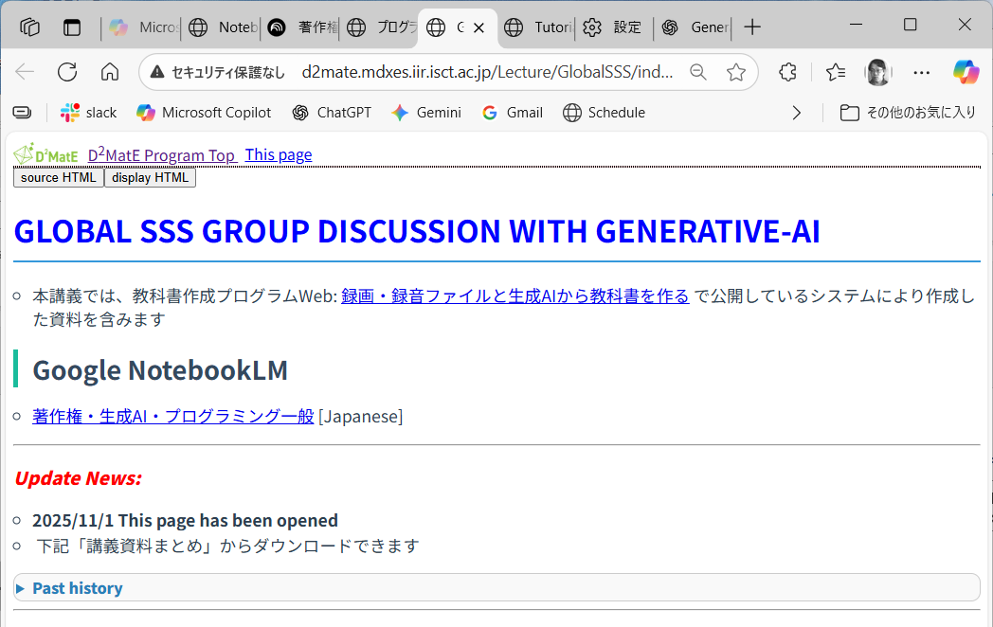

- Statistical Physics (C) Programs: This resource provides AI-powered assistance for making lecture materials such as textbooks, audio guidance and lecture videos, and also solving problems and understanding concepts in statistical physics, a cornerstone of materials science.
http://d2mate.mdxes.iir.isct.ac.jp/D2MatE/D2MatE_programs.html?page=statistics

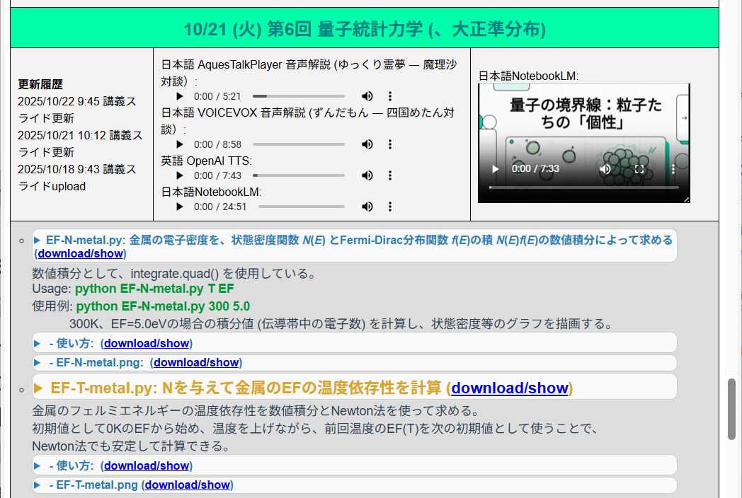

1.3 The Art of the Prompt: An Introduction to Prompt Engineering
The quality of output you receive from a generative AI is directly proportional to the quality of the instructions you provide. This practice of crafting effective instructions is known as Prompt Engineering. Think of it as learning how to communicate effectively with a very powerful, very literal-minded assistant.
A well-crafted prompt should clearly define the following elements:
- Objective (The “What” and “Why”): State precisely what you want to achieve.
  - Weak Prompt: “Talk about meeting minutes.”
  - Strong Prompt: “Summarize the key decisions and action items from the following meeting minutes into a bulleted list.”
- Role (The “Who”): Assign the AI a specific persona or expertise. This constrains the AI’s vast knowledge to a relevant domain, resulting in more focused and accurate responses.
  - Example: “You are a public relations manager. Draft a press release about our new alloy discovery.”
  - Example: “You are a materials science professor. Explain the concept of phase diagrams to a first-year undergraduate student.”
- Target and Context (The “Where” and “For Whom”): Provide the necessary background, including the target audience and the situation.
  - Example: “This is a safety manual for new graduate students working in a wet lab.”
  - Example: “This is a technical presentation for a B2B client interested in our thin-film deposition technology.”
- Output format (The “How”): Specify the desired structure of the output.
  - Example: “Provide the answer in a Markdown table with three columns: ‘Property,’ ‘Value,’ and ‘Measurement Method.’”
  - Example: “Explain this in under 200 words.”
- Constraints (The “Don’ts”): Set boundaries on tone, vocabulary, or content to be avoided.
  - Example: “Explain the concept without using complex jargon.”
  - Example: “Write a product description that avoids making negative comparisons to our competitors.”

1.4 Critical Cautions: Navigating the Pitfalls of Generative AI
While powerful, AI is not infallible. Using it effectively and responsibly requires a healthy dose of skepticism and an awareness of its inherent limitations.
- Misinformation (Hallucinations): This is perhaps the most significant risk. AI models can generate confident-sounding but entirely false or fabricated information. They are designed to produce plausible text, not to state facts.
  - Historical Context: The term “hallucination” in AI was coined to describe these confident but baseless outputs. A famous early example involved an AI creating detailed but non-existent legal case citations.
  - Your Defense: Always independently verify critical information using reliable, primary sources (e.g., peer-reviewed journals, established textbooks). Cross-check facts across multiple trusted sources.
- Prompt Bias: The AI’s response is heavily influenced by the phrasing and assumptions within your prompt. A leading question will almost always produce a biased answer.
  - Your Defense: Frame your prompts neutrally to encourage a balanced response. Instead of “Explain the amazing benefits of solar cells,” ask “Compare the advantages and disadvantages of solar cells.”
- Cognitive Debt: Over-reliance on AI for core thinking tasks can weaken your own critical thinking, problem-solving, and analytical skills. This is a “cognitive debt” you may have to pay back later when faced with a problem you must solve on your own.
  - Your Defense: Use AI as a tool to augment, not replace, your thinking. Always perform the core cognitive work yourself first. Engage with the AI’s output critically, question its reasoning, and make the final judgment yourself.
- Copyright, Privacy, and Security: Public AI models are not secure environments.
  - Your Defense: Never input personal, confidential, or proprietary information. This includes unpublished research data, personal identification information, or confidential company data. Be mindful that your inputs could be used to train future models.

1.5 Advanced Strategies for Deeper Inquiry
Once you have mastered the basics, you can employ more advanced techniques to use AI as a true intellectual partner.

1.5.1 Verification and Critical Reflection
Never accept an AI’s output at face value. Treat it as a hypothesis that requires rigorous testing.
- Demand Evidence: Ask the AI to support its claims.
  - Prompt: “What is the primary source for that statement? Please provide the full citation for the research paper.”
- Change Perspectives: Request the same topic be explained from different viewpoints to reveal hidden assumptions.
  - Prompt: “Now explain the challenges of this new material from the perspective of a manufacturing engineer, not just a research scientist.”
- Request Alternatives: Push the AI to think more broadly.
  - Prompt: “List five potential solutions to this material degradation problem, including at least one unconventional approach.”

1.5.2 Deepening the Dialogue: The Socratic Method
Engage the AI in an iterative conversation to break down complex problems and refine your understanding.
- Critical Analysis: Use the AI to find weaknesses in an argument—even your own.
  - Prompt: “What are the logical gaps or weaknesses in the following argument? Propose three counterarguments.”
- Clarify Assumptions: Uncover the hidden premises behind a conclusion.
  - Prompt: “What are the implicit assumptions that must be true for this conclusion to hold? What happens if those assumptions are violated?”
- Test for Falsifiability: This concept, central to the scientific method and popularized by the philosopher Karl Popper, is about determining whether a hypothesis can be empirically tested and potentially proven false. You can use AI to brainstorm such tests.
  - Prompt: “I hypothesize that adding graphene to this polymer will increase its tensile strength. What experimental design could be used to falsify this hypothesis?”

1.5.3 Simulating a Debate: Multi-Role Discussions
This powerful technique involves instructing the AI to simulate a discussion between multiple experts with different roles and perspectives. This can surface a remarkably diverse range of viewpoints and objections.
- Example Prompt: “You will simulate a debate. Assign one AI the role of a materials scientist focused on the performance of a new solar cell material. Assign a second AI the role of an environmental policy advisor concerned with its lifecycle and recyclability. Assign a third AI the role of a business executive focused on cost and scalability. Have them discuss the viability of this new material.”

1.5.4 Intentional Use of Prompt Bias
While we generally want to avoid bias, we can sometimes use it strategically to “stress-test” an idea or uncover an AI’s blind spots.
- Skeptical Probing: Introduce a counter-argument to the AI’s previous statement to see how it responds.
  - Prompt: “Your previous answer stated that this alloy has excellent corrosion resistance. However, aren’t you underestimating the effects of galvanic corrosion when it’s in contact with stainless steel?”
- Extreme Probing: Push an idea to its logical extreme to reveal potential unintended consequences.
  - Prompt: “You said that this subsidy will accelerate solar panel adoption. Could this lead to a sudden oversupply of panels in 20 years, creating a massive recycling problem?”

1.6 Pro-Tip: Structuring Prompts with Markdown
For complex prompts, using Markdown syntax helps the AI clearly distinguish between instructions, input data, and examples. This significantly improves the reliability and accuracy of the output.
- Delimit Instructions: Use triple backticks (```) to separate your core instructions from the content you want the AI to process.
- Structure Content: Use headings (#, ##), lists (-), and tables to organize your input.
- Handle Code: Use single backticks (`) for inline code and triple backticks with a language specifier (e.g., ```python) for code blocks.
- Emphasize Text: Use asterisks for bold (**bold**) or italics (_italics_) to draw the AI’s attention to key terms.

Complete Prompt Template Examples
Here is a template incorporating many of the principles we’ve discussed.
Example 1: Dialogue
You will now simulate a multi-participant discussion among three AI personas with distinct roles and perspectives. Each persona should respond in turn, addressing others by name and building on previous comments. Keep the discussion balanced, critical, and insightful.

---

## Roles
1. Researcher – A scientist studying solar cells. Focus on technical accuracy, efficiency, and physical principles.
2. Politician – A policymaker designing renewable-energy strategies. Emphasize economic, social, and environmental balance.
3. Company Executive – An industry leader promoting commercialization. Discuss cost, scalability, and business strategy.

---

## Instructions
- Begin with short self-introductions from each role.
- Proceed to a 3-round dialogue, where each participant responds thoughtfully to the others.
- Encourage disagreement, counterarguments, and synthesis of perspectives.
- Conclude with a short summary (1 paragraph) integrating key insights and remaining open questions.

---

## Discussion Topic
[Paste the discussion topic here, for example: “The feasibility of replacing all urban rooftops with next-generation perovskite solar cells within the next 15 years.”]

---

## Output Format
Use the following structure for clarity:
Introductions:
- Researcher: …
- Politician: …
- Company Executive: …

Round 1:
- Researcher: …
- Politician: …
- Company Executive: …
(Continue for all rounds)

Final Summary:
…

Example #2: Rigorous Evaluation of a Research Proposal
You are asked to critically and objectively evaluate the following **research proposal draft** under the conditions below.

---

## Your Role

- **Expertise:** Polymer Engineering (outside the proposal’s research field)
- **Role:** A **strict and candid reviewer** who provides direct, unfiltered feedback
- **Context:** The proposal was written **10 years ago**; evaluate it **from the perspective of current (2025) scientific and technical standards**
- **Goal:** Identify weaknesses and suggest improvements to **maximize the likelihood of funding success**

---

## Evaluation Principles

- No need to consider my feelings — **harsh and honest criticism is encouraged**.
- For every issue you identify, **explain why it is problematic and how it can be improved**.
- Do not hesitate to point out **logical gaps, weak evidence, or outdated concepts**, no matter how small.

---

## Evaluation Criteria

1. **Originality**
- What is truly new or unique in the proposal?
- Are claims of novelty convincing and well-supported?
- Is the distinction from existing work clear?

2. **Feasibility**
- Are the methods and timeline realistic?
- Is the proposed budget appropriate?
- Are the experimental and analytical plans practical and detailed enough?

3. **Flexibility of the Plan**
- Are there contingency or backup strategies if the project does not proceed as planned?
- Does the proposal demonstrate adaptability and resilience?

4. **Comparison with Previous Studies**
- Why is this research superior to prior work?
- Are the comparisons with previous studies sufficient and up to date?
- Is the literature review comprehensive and accurate?

5. **Societal Significance**
- How will this research contribute to society or industry?
- Are the potential impacts and applications described concretely?
- Is the claimed significance more than just abstract statements?

---

## Output Format (Example)

1.7 Further Resources
For additional tutorials and examples, please refer to the following resources (note: contents are in Japanese).
- Tutorial Web: http://d2mate.mdxes.iir.isct.ac.jp/D2MatE/D2MatE_programs.html?page=tutorial
